**REPORT**

Tableau software helps in better visualization and effective communication. Credit risk modelling dataset was cleaned and opened in tableau. The following visualizations were made, and inferences were drawn:

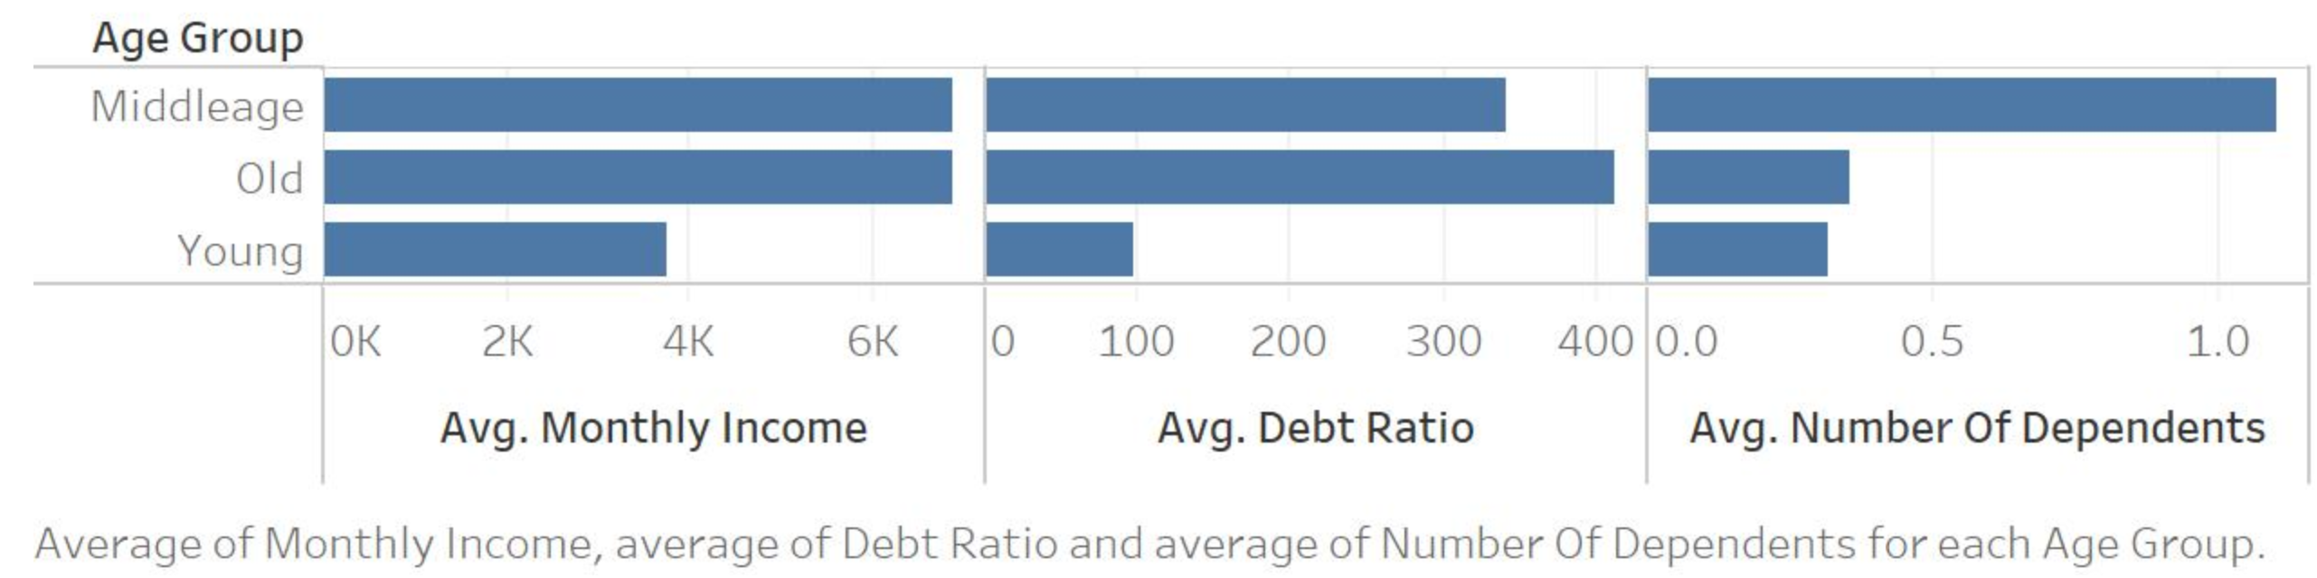

*Inference:*

The middleage and old people earned almost the same on an average and younger lot the least. The old people have highest debt ratio. The average number of dependents is much higher for middle age people.

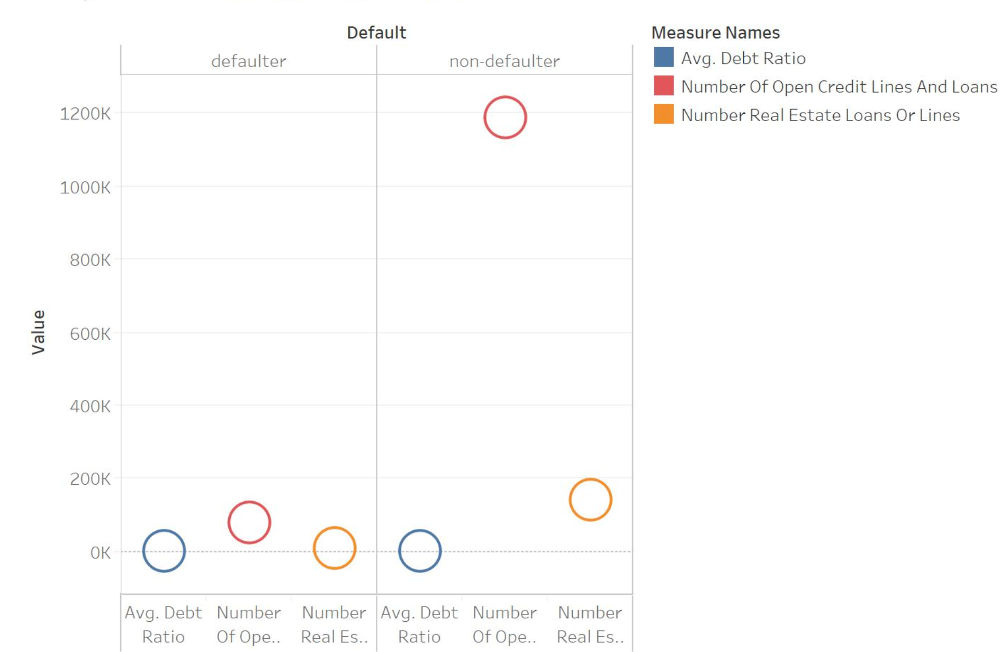

*Inference:*

The average debt ratio is almost the same for both defaulters and non-defaulters. Ironically Number of unsecured and secured loans are much higher for defaulters.

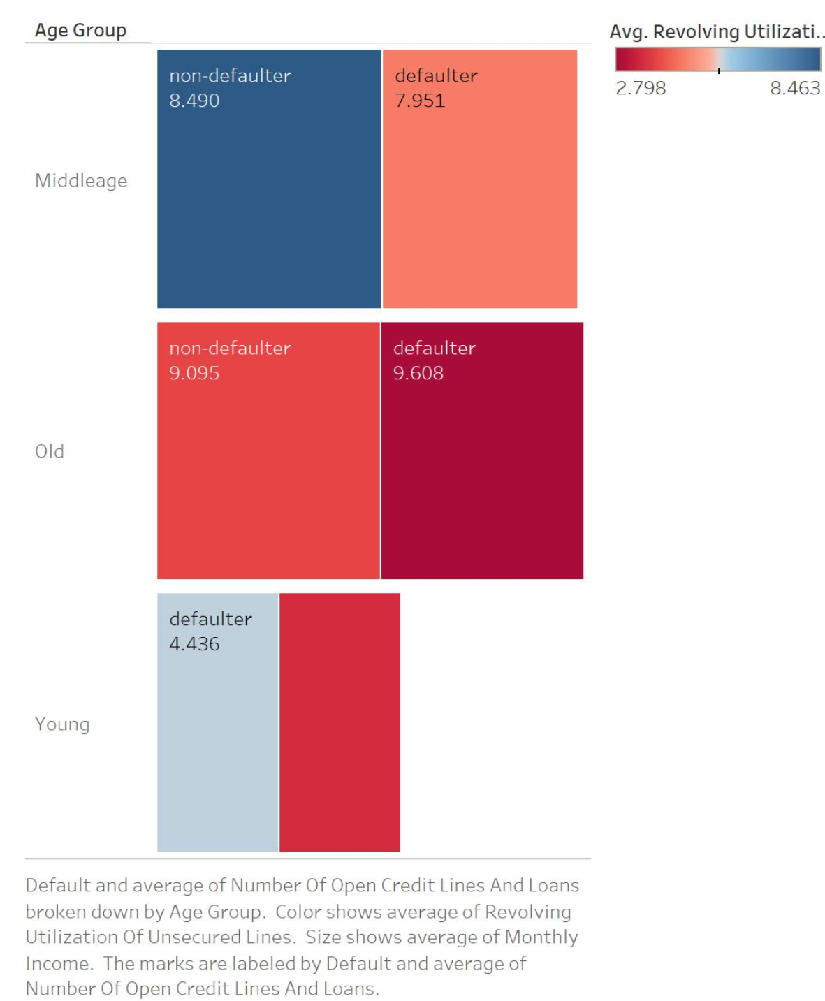

*Inference:*

Avg number of open credit lines are highest for old aged defaulters with least average revolving utilization.

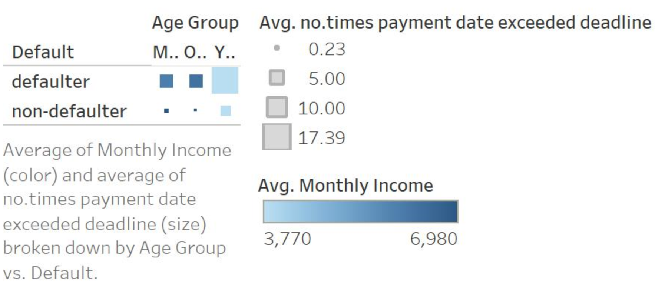

*Inference:*

Young people who earn less have exceeded the deadline most of the time as expected.

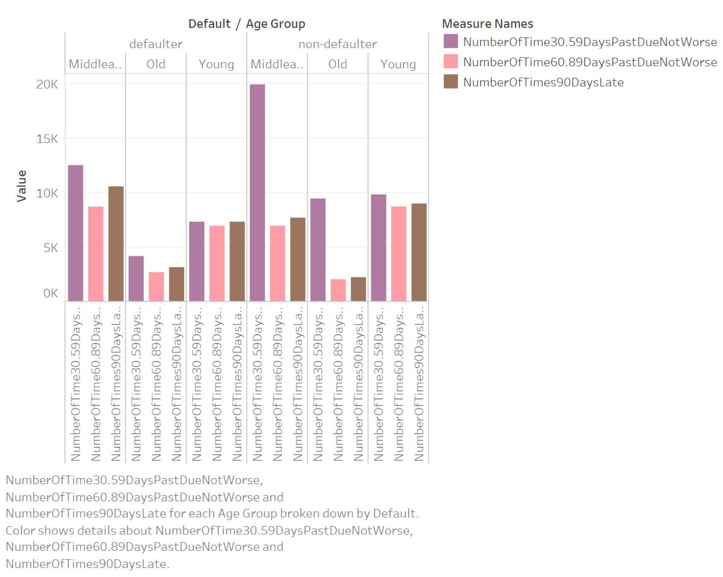

*Inference:*

On an average the middle age people who are non-defaulters mostly have exceeded 30-59 days from deadline of paying back. The middle age defaulters and non-defaulters who are young have exceeded 60-89 days from deadline of paying back. On an average the middle aged people whether defaulters or non-defaulters have exceeded 90 days from deadline of paying back.

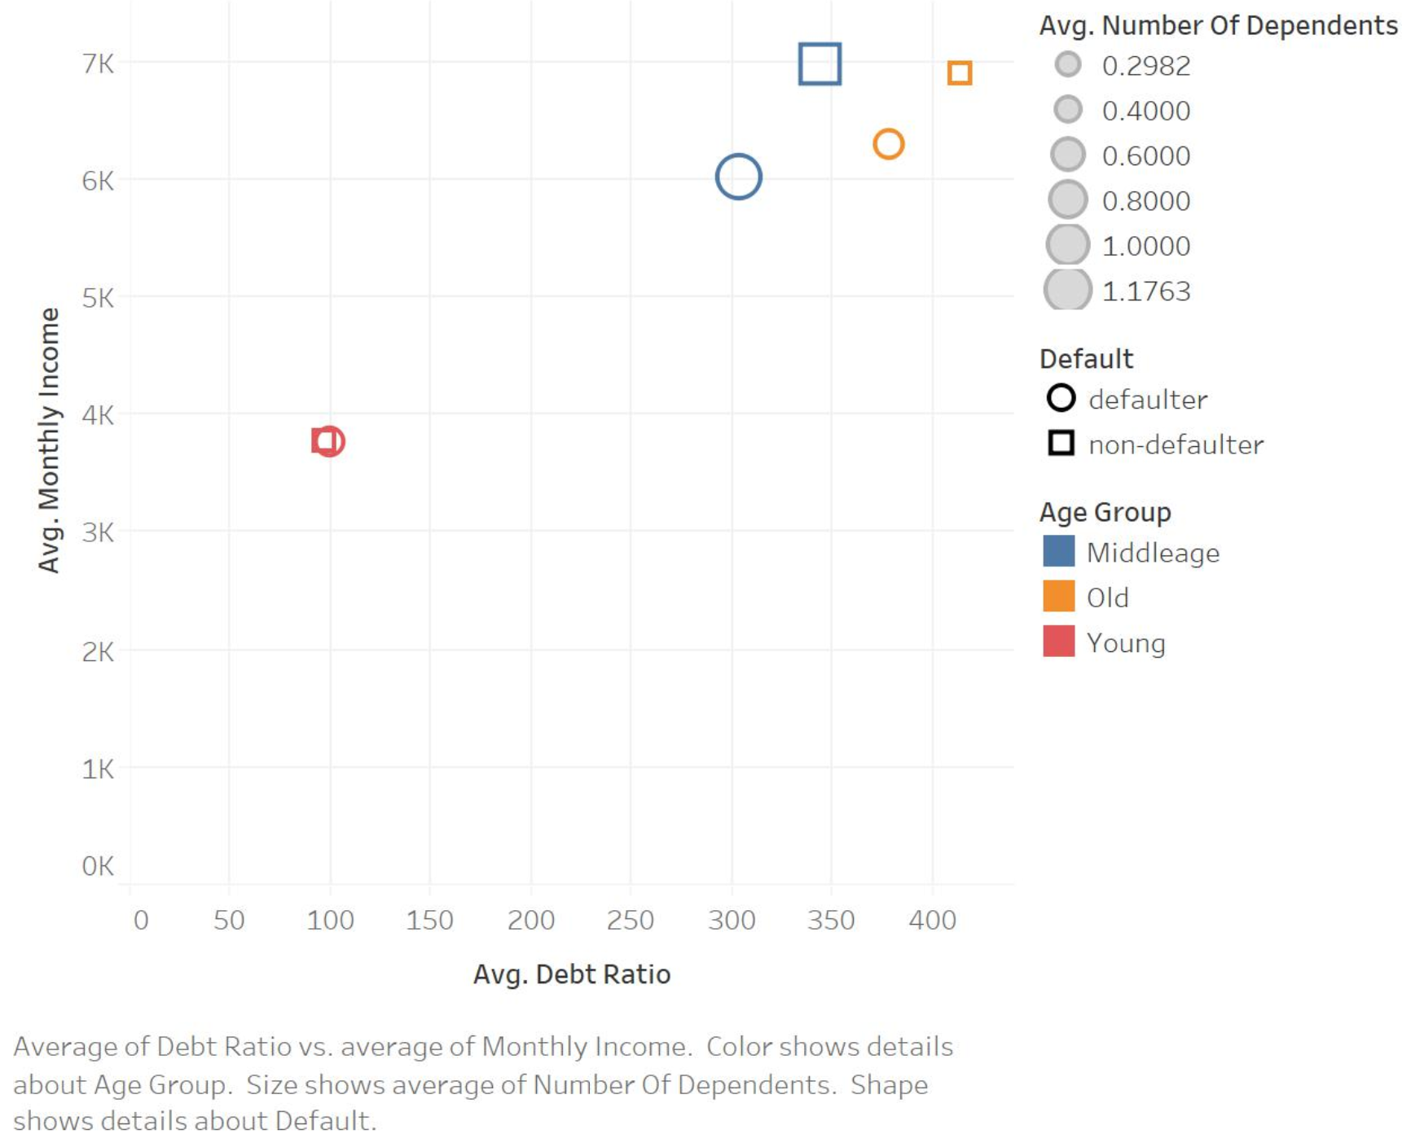

Young people having almost the same income and avg debt ratio are both defaulters and non defaulters.Middleage people with the most number of dependents with high income and high debt ratio.

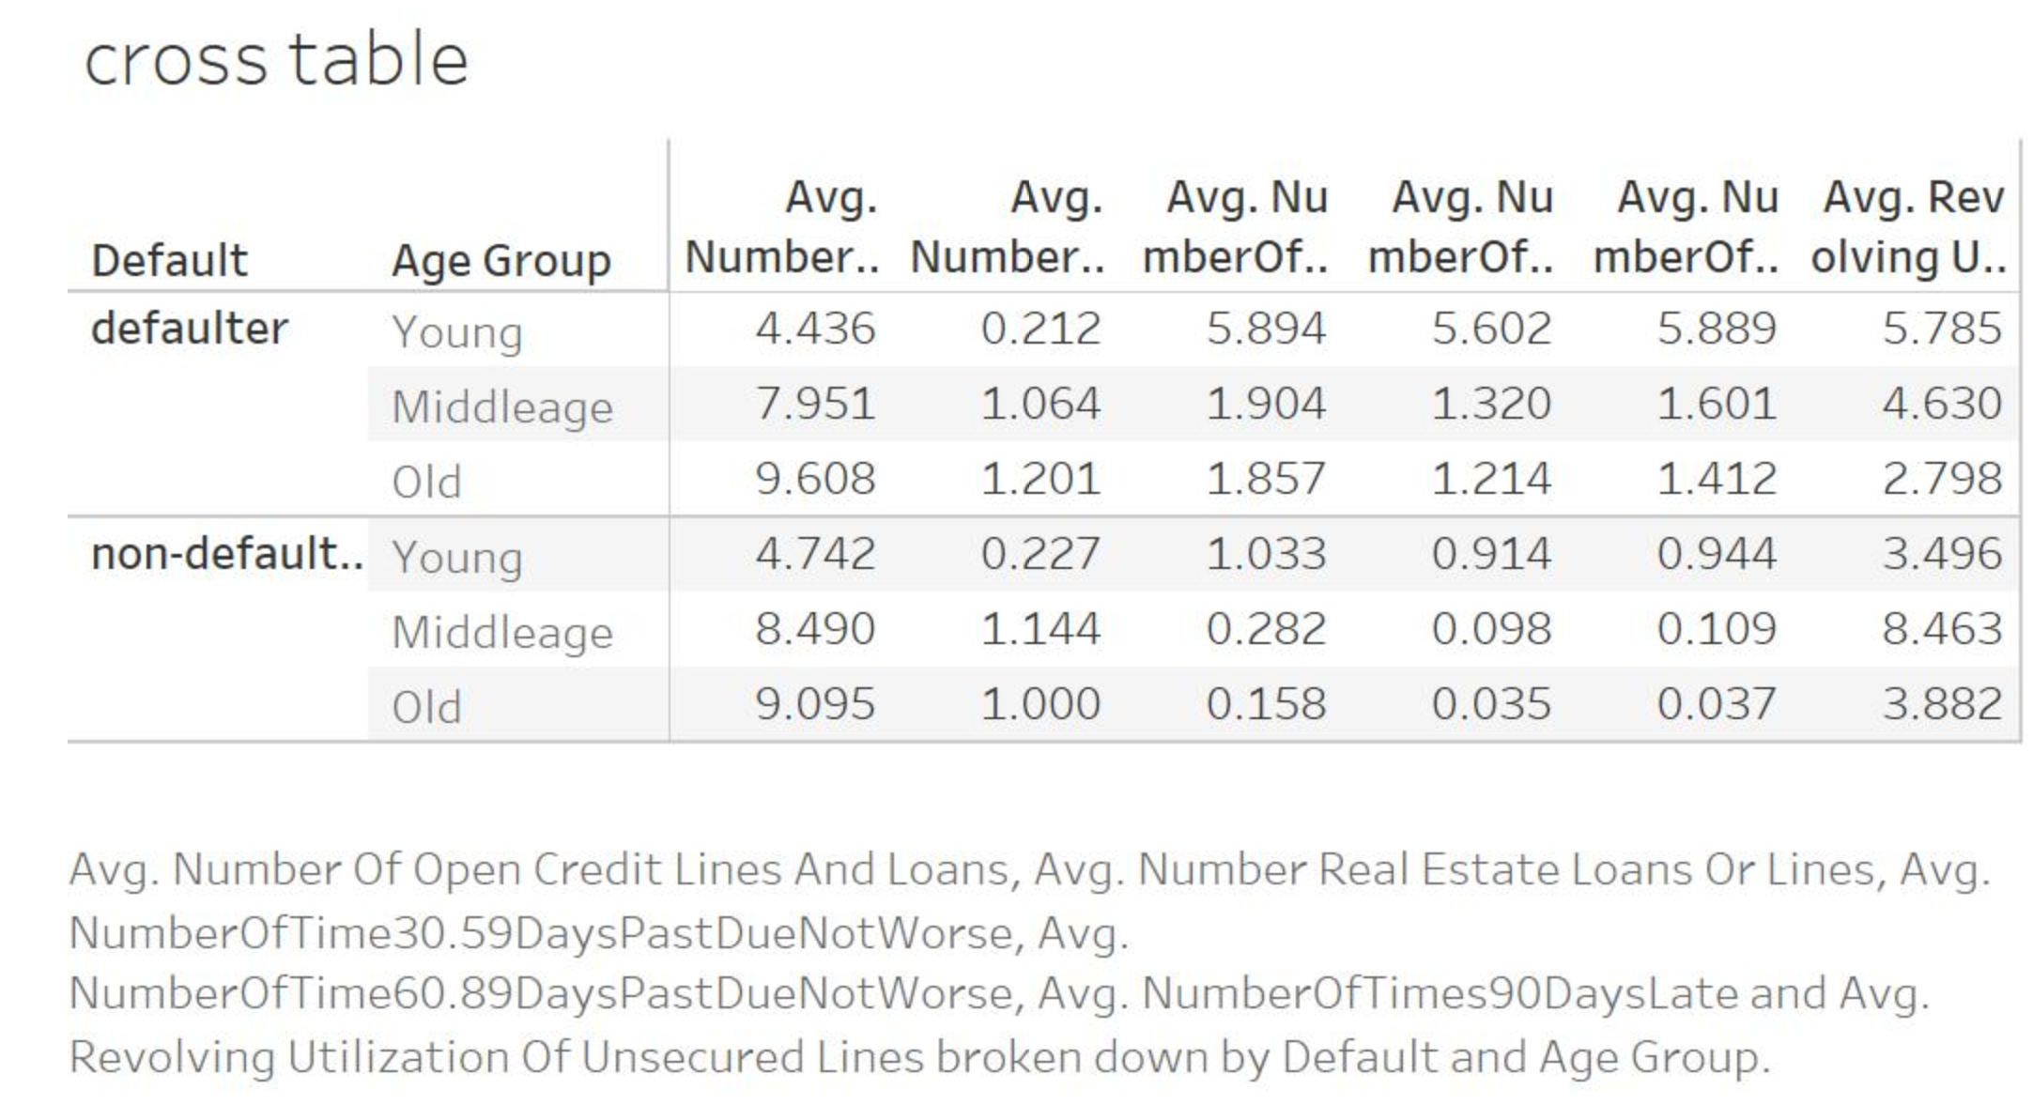

A cross table has been plotted between age group, defaulters vs avg number of open credit. It is found that the avg number of old people who are non defaulters who have exceeded the payment deadline by 30-59 days is high in number. The old and non-defaulters & middle aged non defaulters have not exceeded the deadline much.The average number of open credit lines and loans is almost the same for both defaulters and non-defaulters for respective age group.The average revolving utilization for young non-defaulters is lesser than the defaulters.

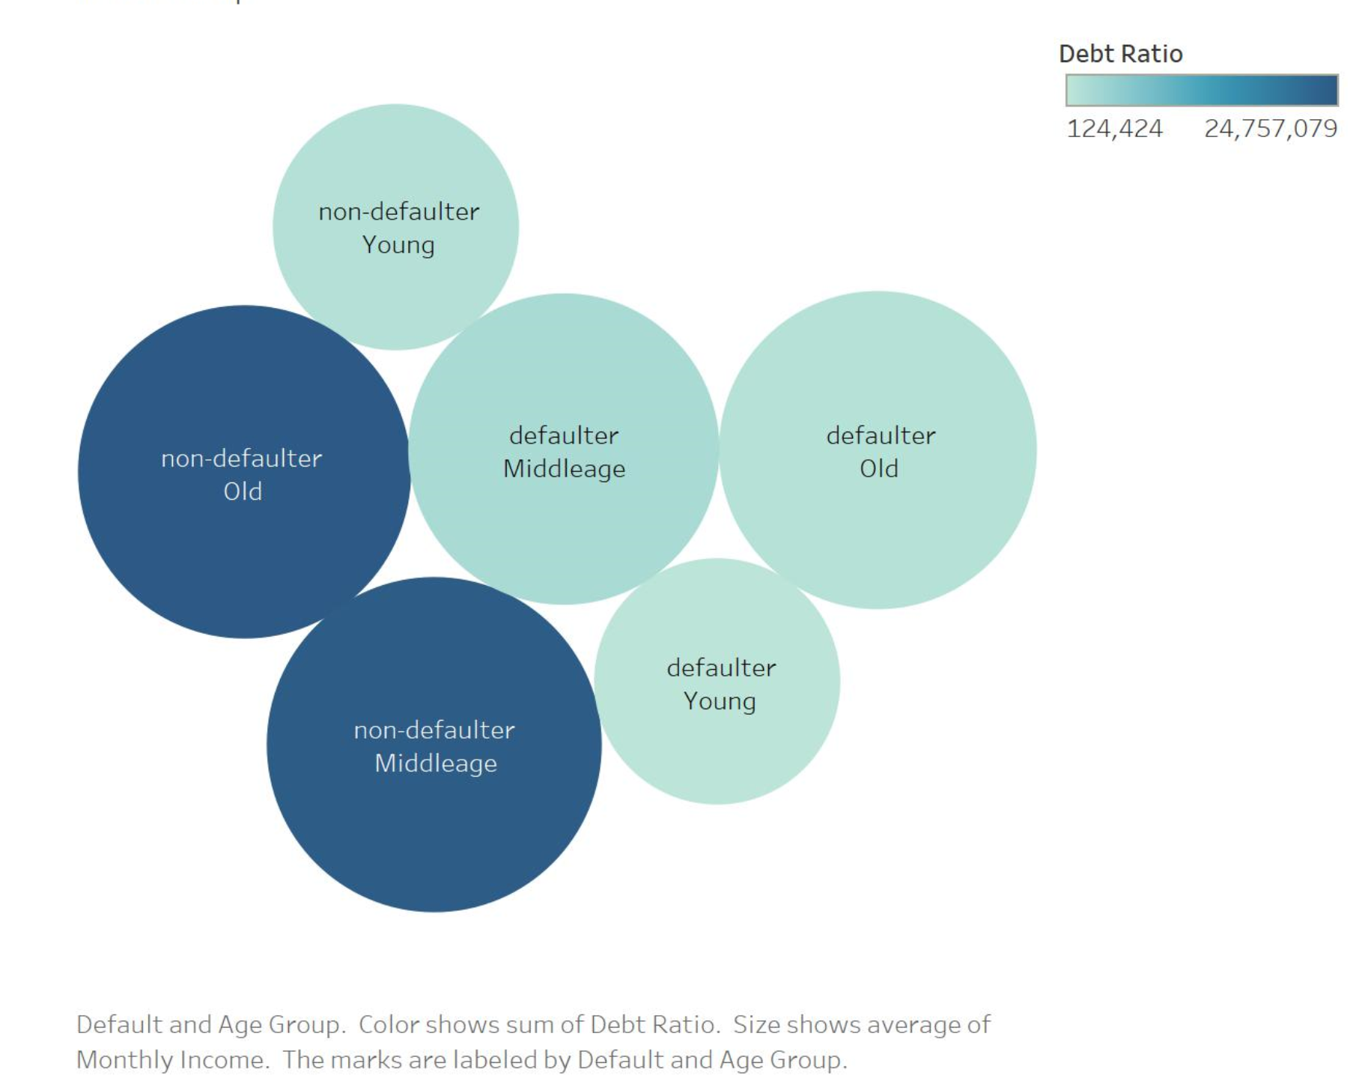

The old and middle aged non-defaulters have high income and high debt ratio.This is followed by old and middle aged defaulters.Almost equal number of young adults are both defaulters and non-defaulters with less income and low debt ratio.

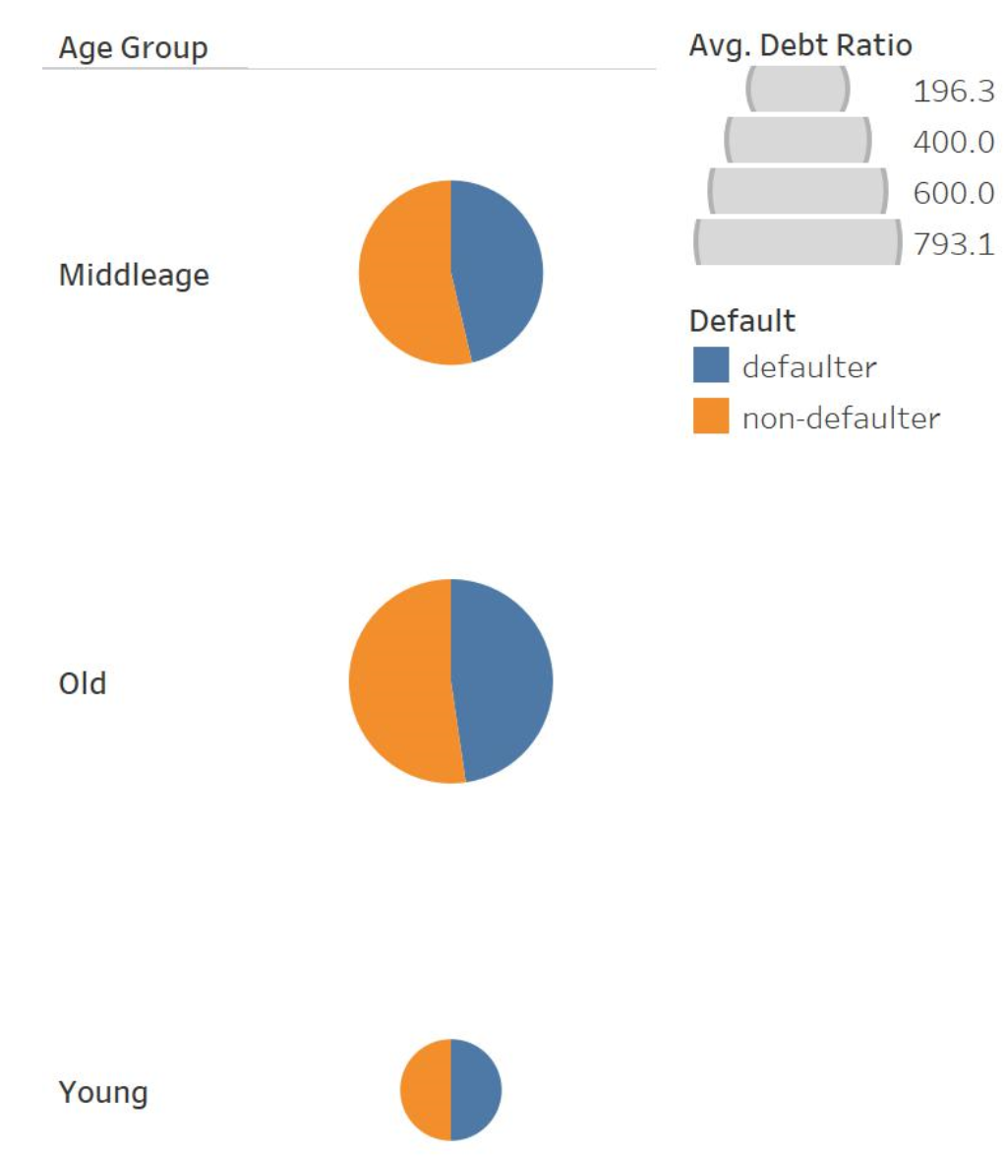

The average number of defaulters and non-defaulters are almost same for each age group given their respective avg. income and debt ratio.